Buffalo Lake 2024 Fish Stocking

On May 22nd, 2024 the Buffalo Lake fish committee stocked
$8k worth of fish in Buffalo Lake.

Species | Minimum order | Unit Price | Quantity | Subtotal
Largemouth bass 4-6" | 10/ea | $5.76 | 800 | $4,608.00
Black crappie 3-5" | 25/ea | $3.00 | 600 | $1,800.00
Yellow perch 4-6" | 10/ea | $4.00 | 500 | $2,000.00
Yellow perch 2-4" | 25/ea | $2.00 | 900 | $1,800.00
Sub-total |  |  |  | $10,208.00
Order discount: |  |  | 25% | -$2,552.00
Transportation & Delivery to: | Marquette |  |  | $375.00
Tax Exempt? | Yes | Sales Tax |  | $0.00
TOTAL* |  |  |  | $8,031.00

The stocking was headed by Gary Doudna the fish committee co-chair.
With the lowered water level by Wis. DNR, until May 20th annually, the ability of boats to navigate was restricted. Several committee members assisted stocking at various shore locations throughout Buffalo Lake.

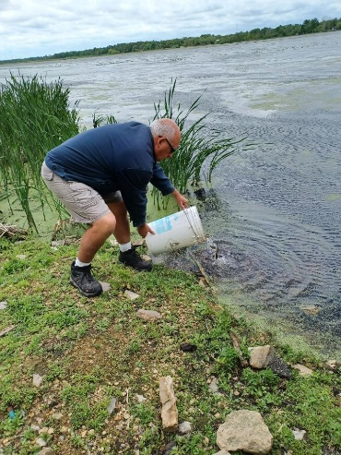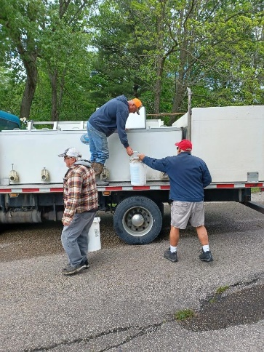
Gary Doudna stocking fish Gary Kershaw, Gary Doudna
unloading fish.
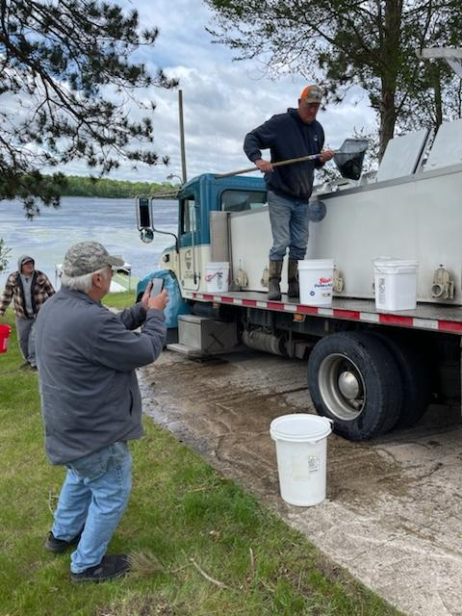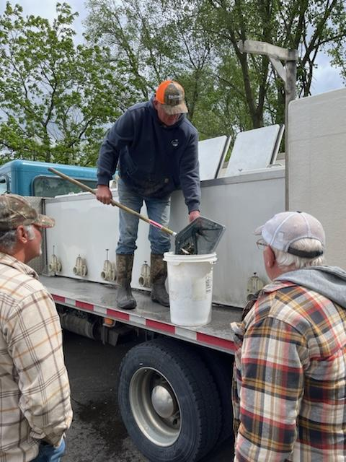
Mike Marine Dan Braaksma & Gary Kershaw

The following area businesses support Buffalo Lake by contributing to an annual fund used to stock the lake with fish each Spring. District members can show their support by patronizing these businesses -- and be sure to mention your appreciation. If you'd like more information, contact the Fish Committee chairs. Check out our web site and Facebook page for details.
Please patronize these businesses and tell them thank you!

Walker Insurance Agency | 'Tween the Lakes Motel | Piers Plus | Rendezvous Paddle & Sports | Kathleen's Flour Bin | Johnson's Boats & Motors | Holliday Shopping Center | Hoffmann Tree Service | Drews Lakeside Bar and Grill | Gina Kloostra-Burmania Cotter Realty | Buffalo Lake Camping Resort | River's Edge Saloon & Eatery

